Programming recall
Y11 - Cambridge IGCSE 0478 | Paper 2 recap of Year 10 | Student booklet
Name: _______________________________ | Date: _____________

This booklet has everything you need for the lesson in one place. Work through it in order:
- Learn sections show the key slides. Read them carefully - they explain the ideas and show worked examples.
- Task sections are where you practise. Each task uses what the slides just before it taught you.
- Tasks get harder as you go and use real Cambridge 0478 Paper 2 questions. Task 8 is an extension.
Do Task 1 from memory before you turn the page - it shows what you remember from Year 10.
Task 1 Retrieval check [5 marks]
From memory. Write TRUE or FALSE for each statement. If it is false, write a correct version.
# | Statement | True / false | Correction if false
1 | A REPEAT ... UNTIL loop always runs at least once.
2 | A WHILE ... DO loop checks its condition after the loop body has run.
3 | A telephone number such as 07812 345678 should be stored as an INTEGER.
4 | DIV(17, 5) returns 3 and MOD(17, 5) returns 2.
5 | ROUND(RANDOM() * 6, 0) generates a whole number from 1 to 6.

Learn Data, operators and library routines
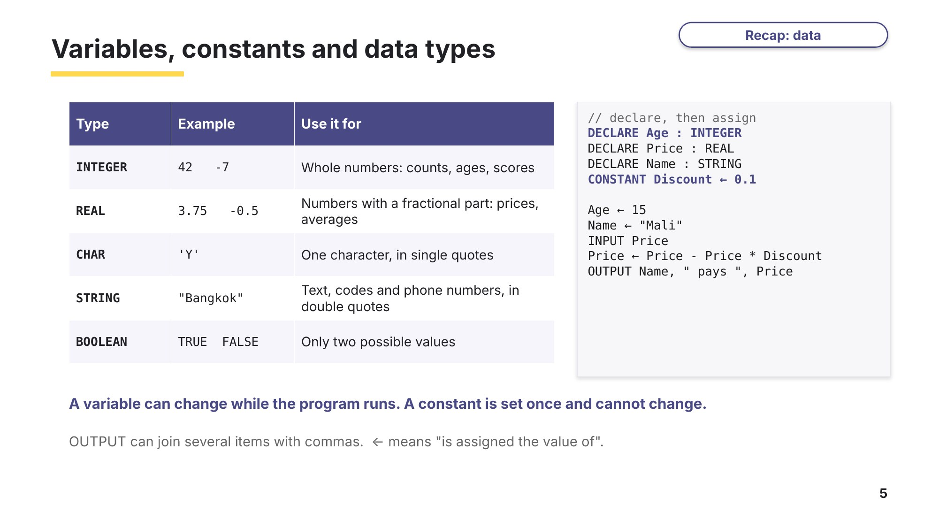
Slide 5 - Variables, constants and data types
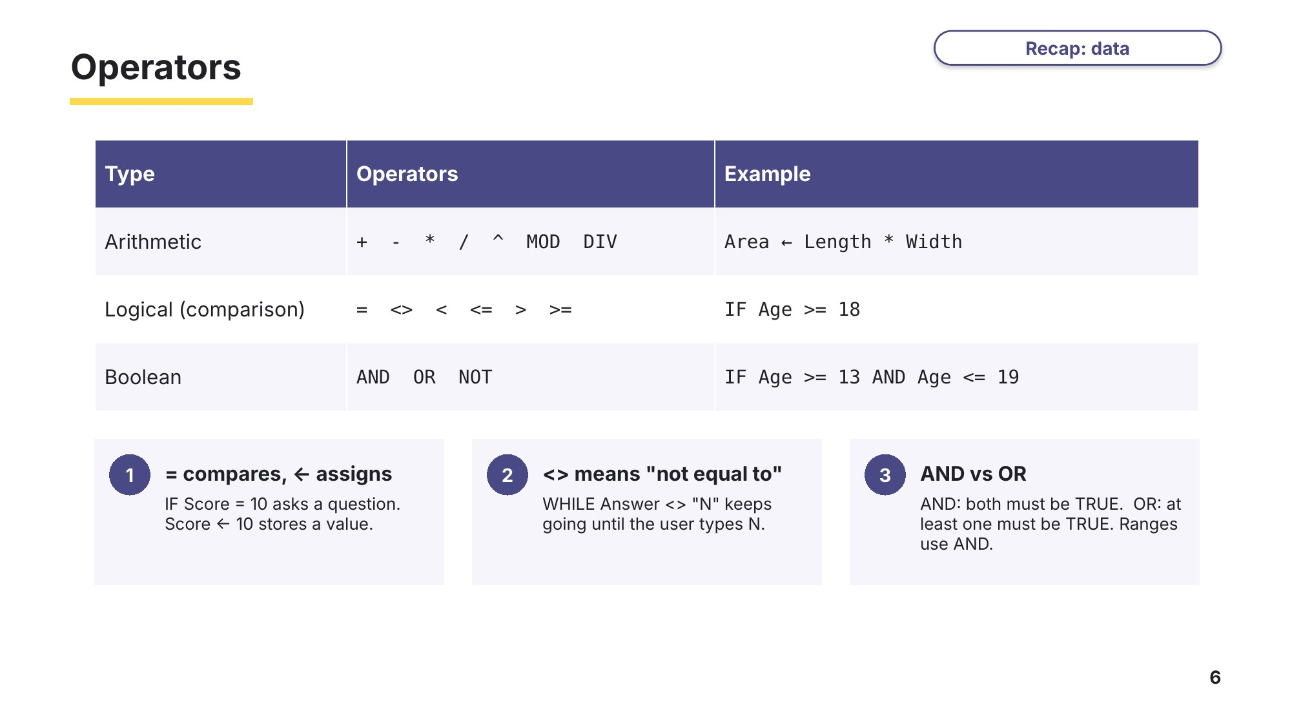
Slide 6 - Operators
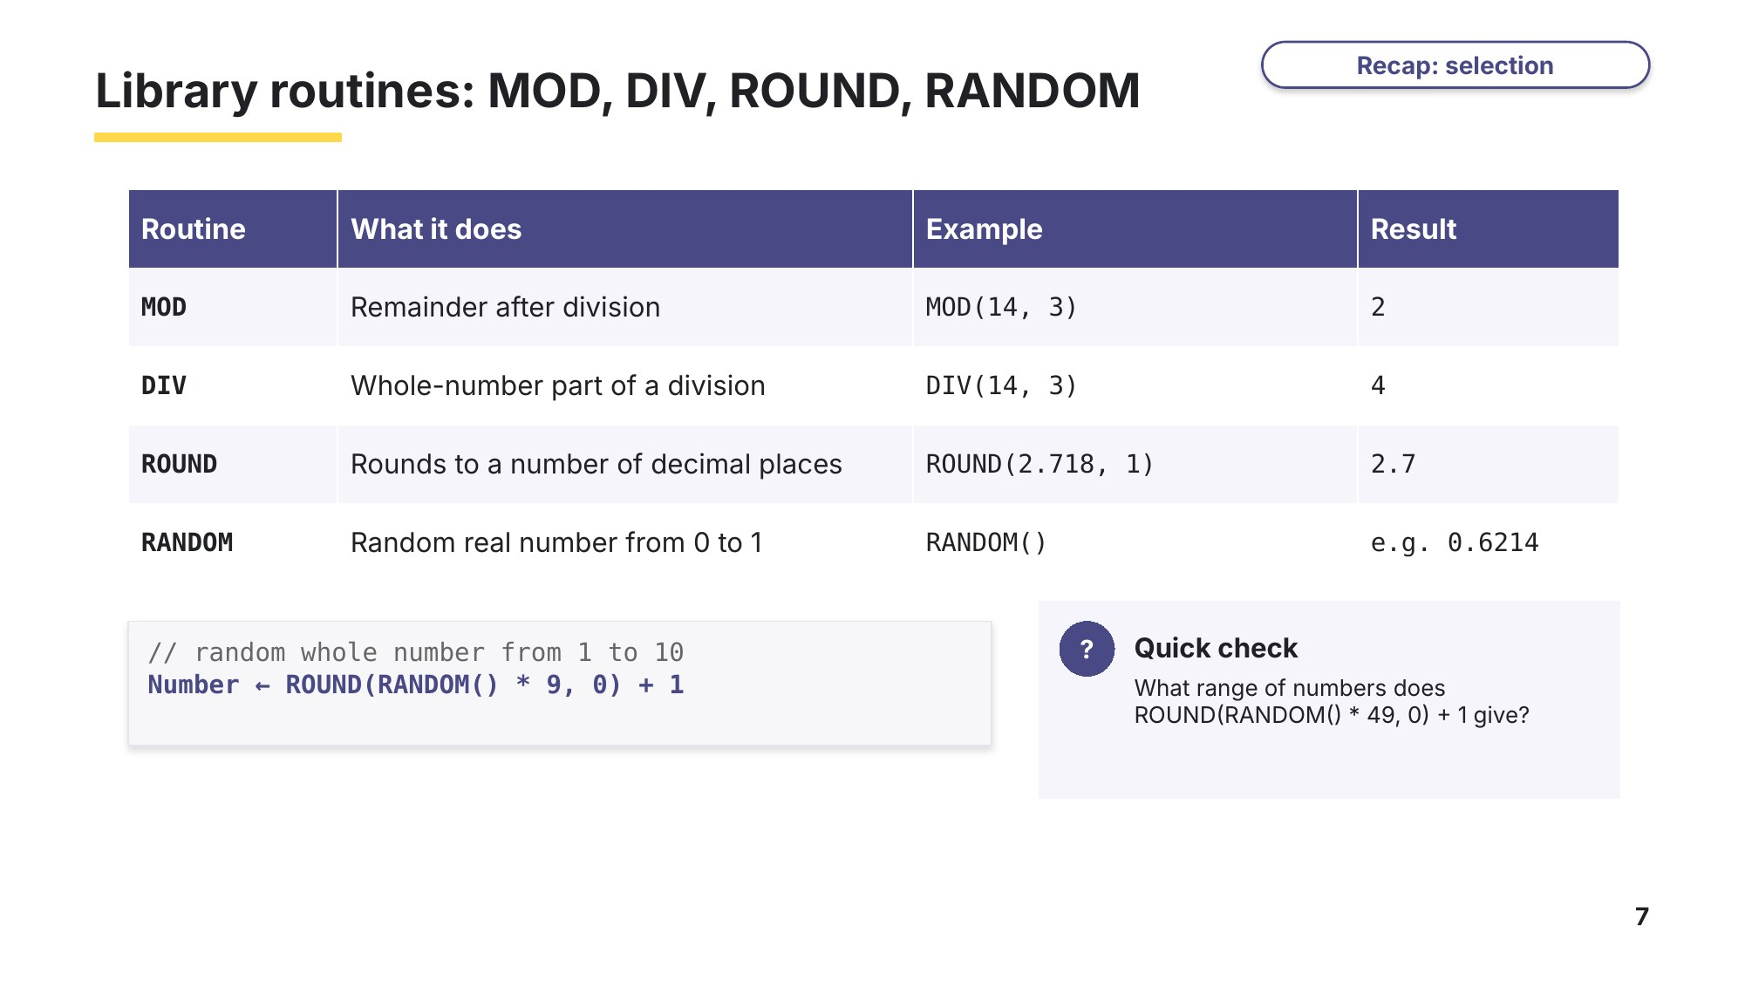
Slide 7 - Library routines
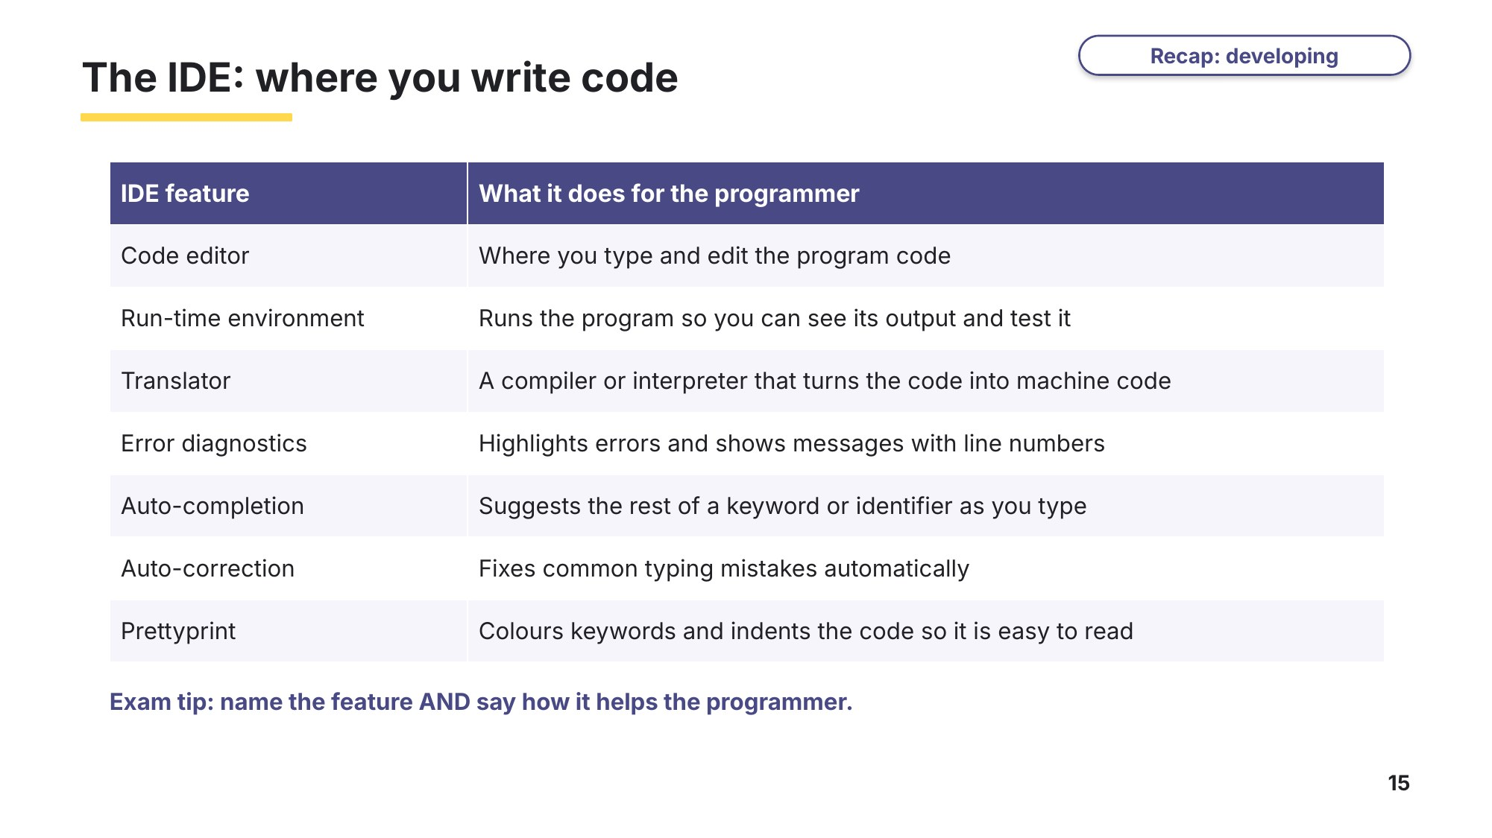
Slide 15 - The IDE

Task 2 Data, operators and library routines [31 marks]
(a) Write the most appropriate data type for each item of data. [3]
Data | Data type
The number of pupils in a class
The price of a cinema ticket, for example 6.50
Whether a door is locked or not
A pupil's grade, for example 'B'
A telephone number, for example 0812345678
The name of a city

(b) Describe the data types integer and real. Give an example of data for each. [4]
0478/21 May/June 2024 Q3
Integer

Real

(c) Write pseudocode to declare a variable City as a string and assign it the value Bangkok; declare a variable Initial as a character and assign it the value M; and declare a constant MaxPlayers with the value 4. [3]
Based on 0478/22 May/June 2023 Q11(a) and 0478/21 May/June 2025 Q9(a)

(d) Explain the difference between a variable and a constant. [2]

(e) Describe arithmetic, Boolean and logical operators. Give an example of pseudocode for each type of operator. [6]
0478/22 May/June 2024 Q5
Arithmetic

Boolean

Logical

(f) Describe the library routines MOD and DIV. Use a pseudocode example for each one. [4]
0478/21 May/June 2025 Q5
MOD

DIV

(g) Write the value returned by each expression. [4]
Expression | Value | Expression | Value
MOD(23, 4) |  | ROUND(7.386, 2)
DIV(23, 4) |  | ROUND(15.5 / 4, 1)

(h) (i) Write one pseudocode statement that stores a random whole number from 1 to 6 in the variable Dice. [2]

(ii) A program contains the statement Limit ← ROUND(RANDOM() * 19, 0) + 1. State the smallest and largest values that Limit can have. [1]
Line 06 of 0478/21 May/June 2024 Q4

(i) Name two features of an integrated development environment (IDE) and say how each one helps a programmer. [2]
Exam-style (syllabus 4.2, examined on Paper 1)

Learn Selection
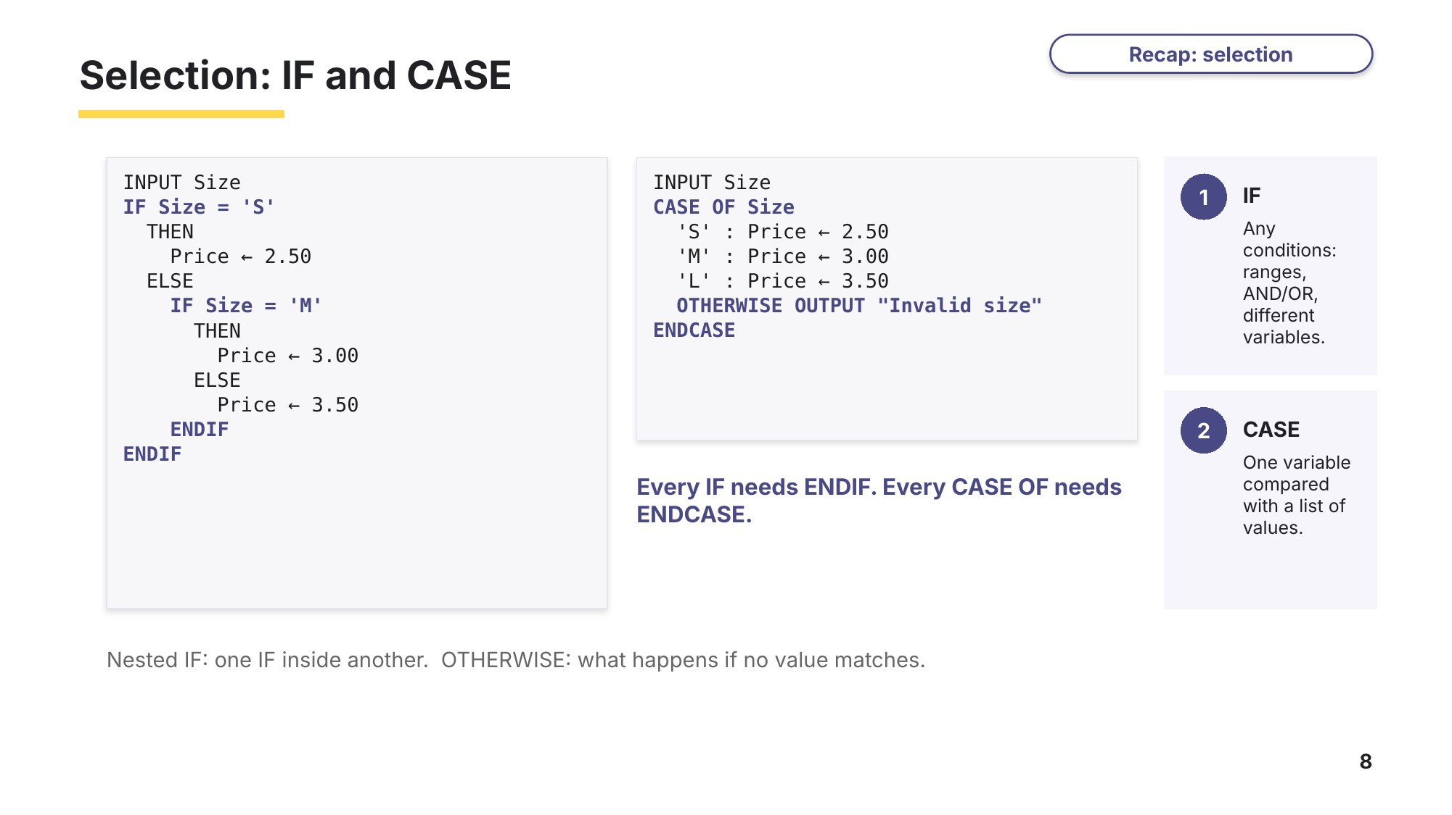
Slide 8 - IF and CASE
Task 3 Selection [17 marks]
(a) A game has a menu. Write an algorithm in pseudocode that inputs a menu choice and uses a CASE statement to output "New game" for 1, "Load game" for 2, "Settings" for 3 and "Quit" for 4. Any other input outputs "ERROR". [5]
Based on 0478/21 May/June 2024 Q5

(b) A cinema charges by age: under 5 is free (0.00), 5 to 15 is 6.50, 65 and over is 7.00 and everyone else pays 10.00. Write an algorithm in pseudocode that inputs an age and uses IF statements to output the ticket price. [4]
Exam-style

(c) This algorithm inputs two non-zero numbers and a sign, then performs the calculation shown by the sign. An input of zero for the first number ends the process.
0478/22 May/June 2018 Q3
INPUT Number1, Number2, Sign
WHILE Number1 <> 0 DO
IF Sign = '+' THEN Answer ← Number1 + Number2 ENDIF
IF Sign = '-' THEN Answer ← Number1 - Number2 ENDIF
IF Sign = '*' THEN Answer ← Number1 * Number2 ENDIF
IF Sign = '/' THEN Answer ← Number1 / Number2 ENDIF
IF Sign <> '/' AND Sign <> '*' AND Sign <> '-' AND Sign <> '+'
THEN Answer ← 0
ENDIF
IF Answer <> 0 THEN OUTPUT Answer ENDIF
INPUT Number1, Number2, Sign
ENDWHILE
(i) Complete the trace table for the input data: 5, 7, +, 6, 2, -, 4, 3, *, 7, 8, ?, 0, 0, / [3]
Number1 | Number2 | Sign | Answer | OUTPUT

(ii) Show how you could improve the algorithm by writing an alternative type of conditional statement in pseudocode. [3]

(d) Explain when a CASE statement is a better choice than IF statements. [2]

Learn Iteration, counting and totalling
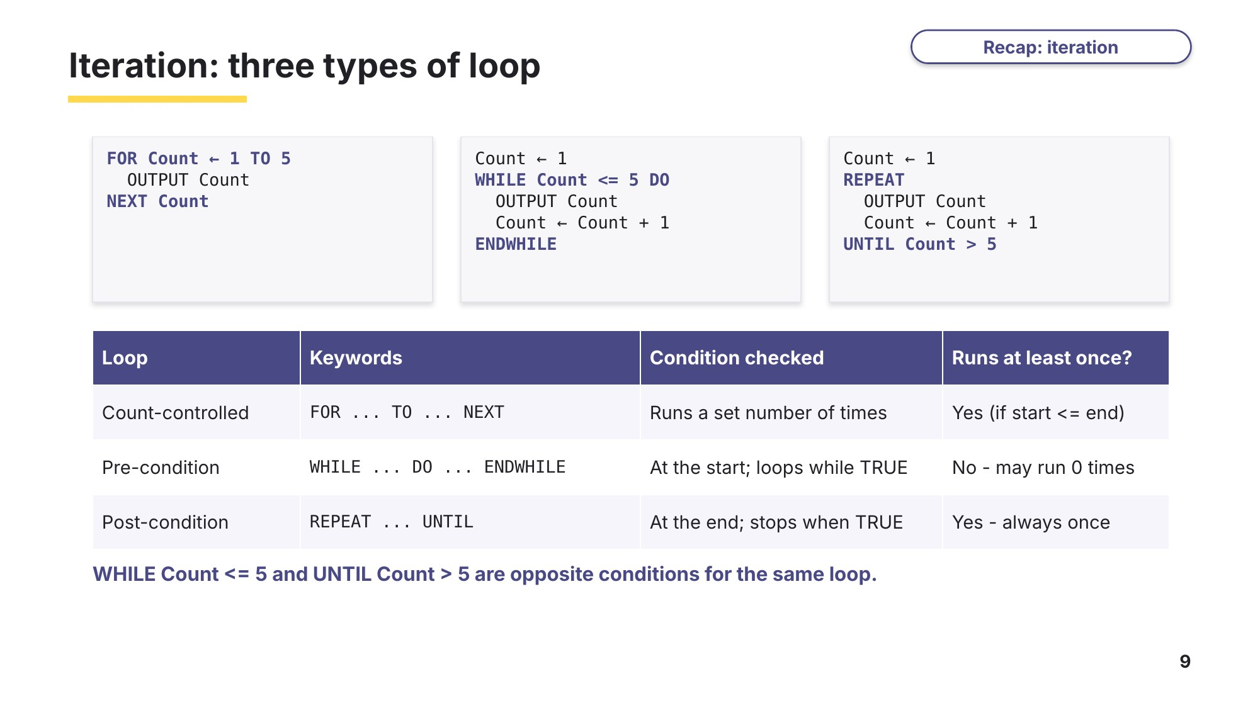
Slide 9 - Three types of loop
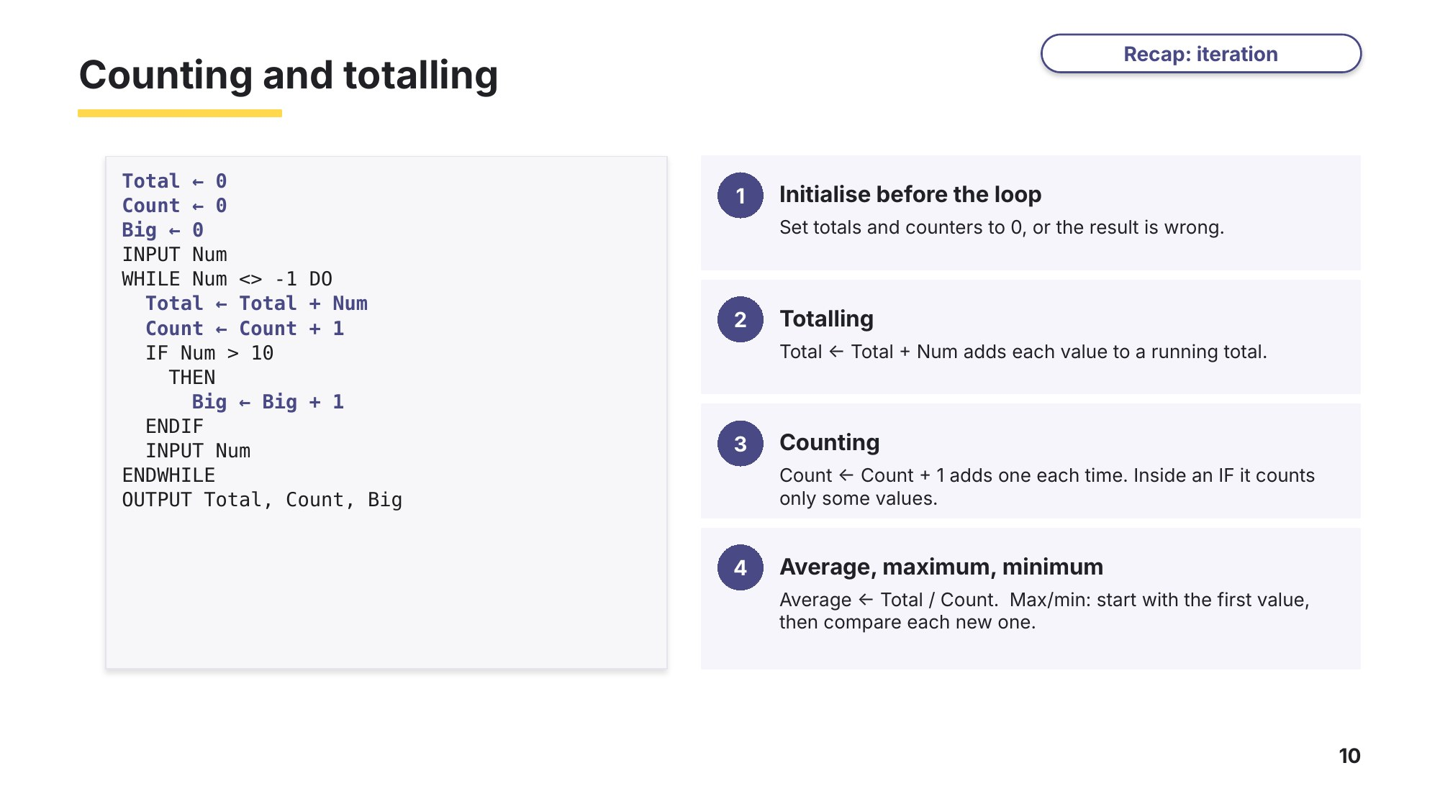
Slide 10 - Counting and totalling

Task 4 Iteration, counting and totalling [26 marks]
(a) Name the three types of loop used in pseudocode and give the keywords used to write each one. [3]
Exam-style

(b) This algorithm uses a count-controlled loop to input and total 10 temperatures.
Total ← 0
FOR Count ← 1 TO 10
OUTPUT "Please enter a temperature"
INPUT Temp
Total ← Total + Temp
NEXT Count
OUTPUT Total
Rewrite the algorithm using a condition-controlled loop that does the same job. [4]
Based on 0478/21 May/June 2025 Q3 (the original stores 10 names in an array)

(c) Write an algorithm in pseudocode to input a series of numbers and output the total of the numbers. The value 9999.9 is used to stop the input and must not be added to the total. [4]
Based on 0478/22 May/June 2024 Q6(a)

(d) Write an algorithm in pseudocode to input a series of numbers, ending with 9999.9, and output how many of the numbers are greater than 100. [4]
Based on 0478/22 May/June 2024 Q6(b)

(e) Write an algorithm in pseudocode to input 20 numbers. Output the largest number, the smallest number and the average of the numbers rounded to one decimal place, each with a suitable message. [6]
Exam-style

(f) A cinema booking system asks how many seats are wanted. The number must be a whole number from 1 to 6. Write an algorithm in pseudocode that inputs the number of seats and makes the user enter it again, with a suitable message, until it is valid. [5]
Based on 0478/23 Oct/Nov 2023 Q4(b)

Learn Check your Task 4 answers
Only look at this slide once you have finished Task 4. Mark (c) against the official marking points, then use the same idea to mark (d).
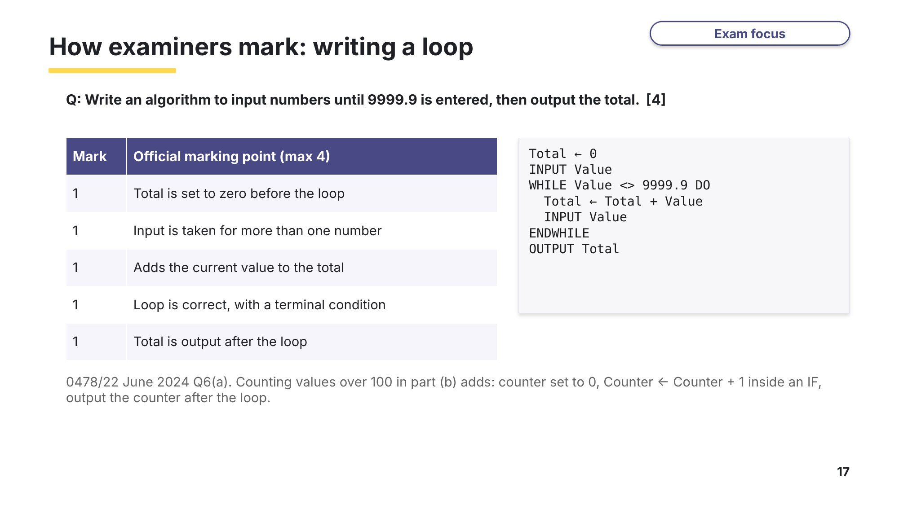
Slide 17 - How examiners mark: writing a loop

Learn Trace tables and flowcharts
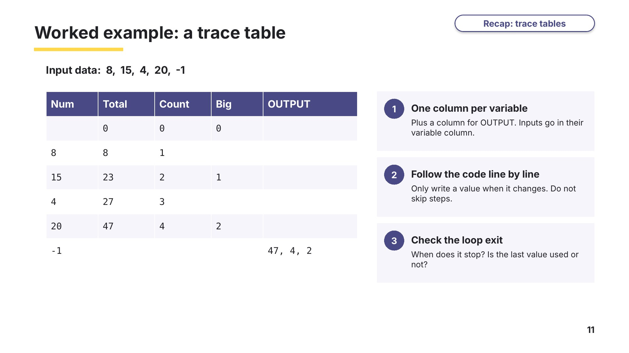
Slide 11 - Worked example: a trace table
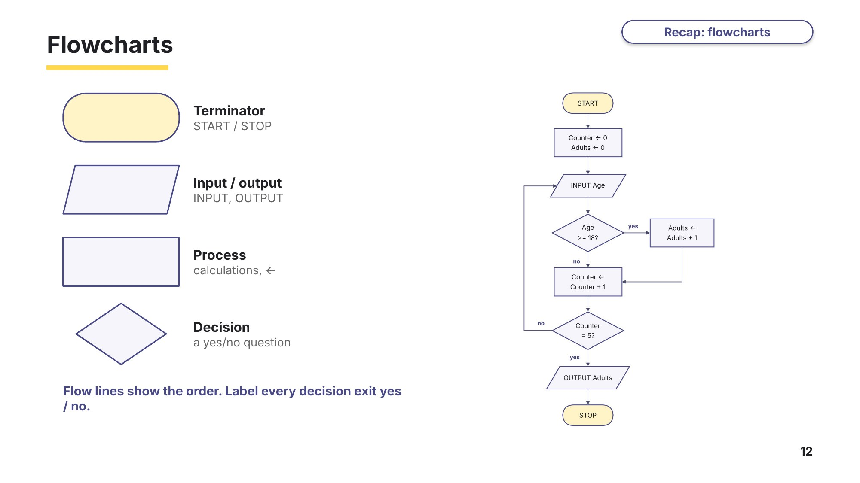
Slide 12 - Flowcharts

Task 5 Trace tables and flowcharts [25 marks]
(a) Name each flowchart symbol and state what it is used for. [4]
Exam-style
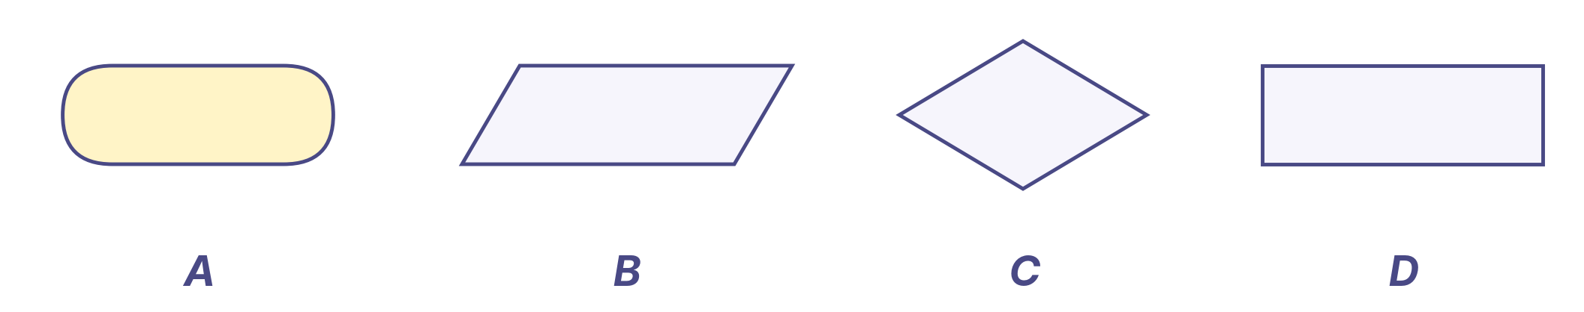
Symbol | Name | Used for
A
B
C
D

(b) This flowchart checks the size of a consignment of ten parcels. The dimensions of each parcel are input in centimetres.
Cambridge IGCSE Computer Science coursebook (Hodder), exam-style question 6
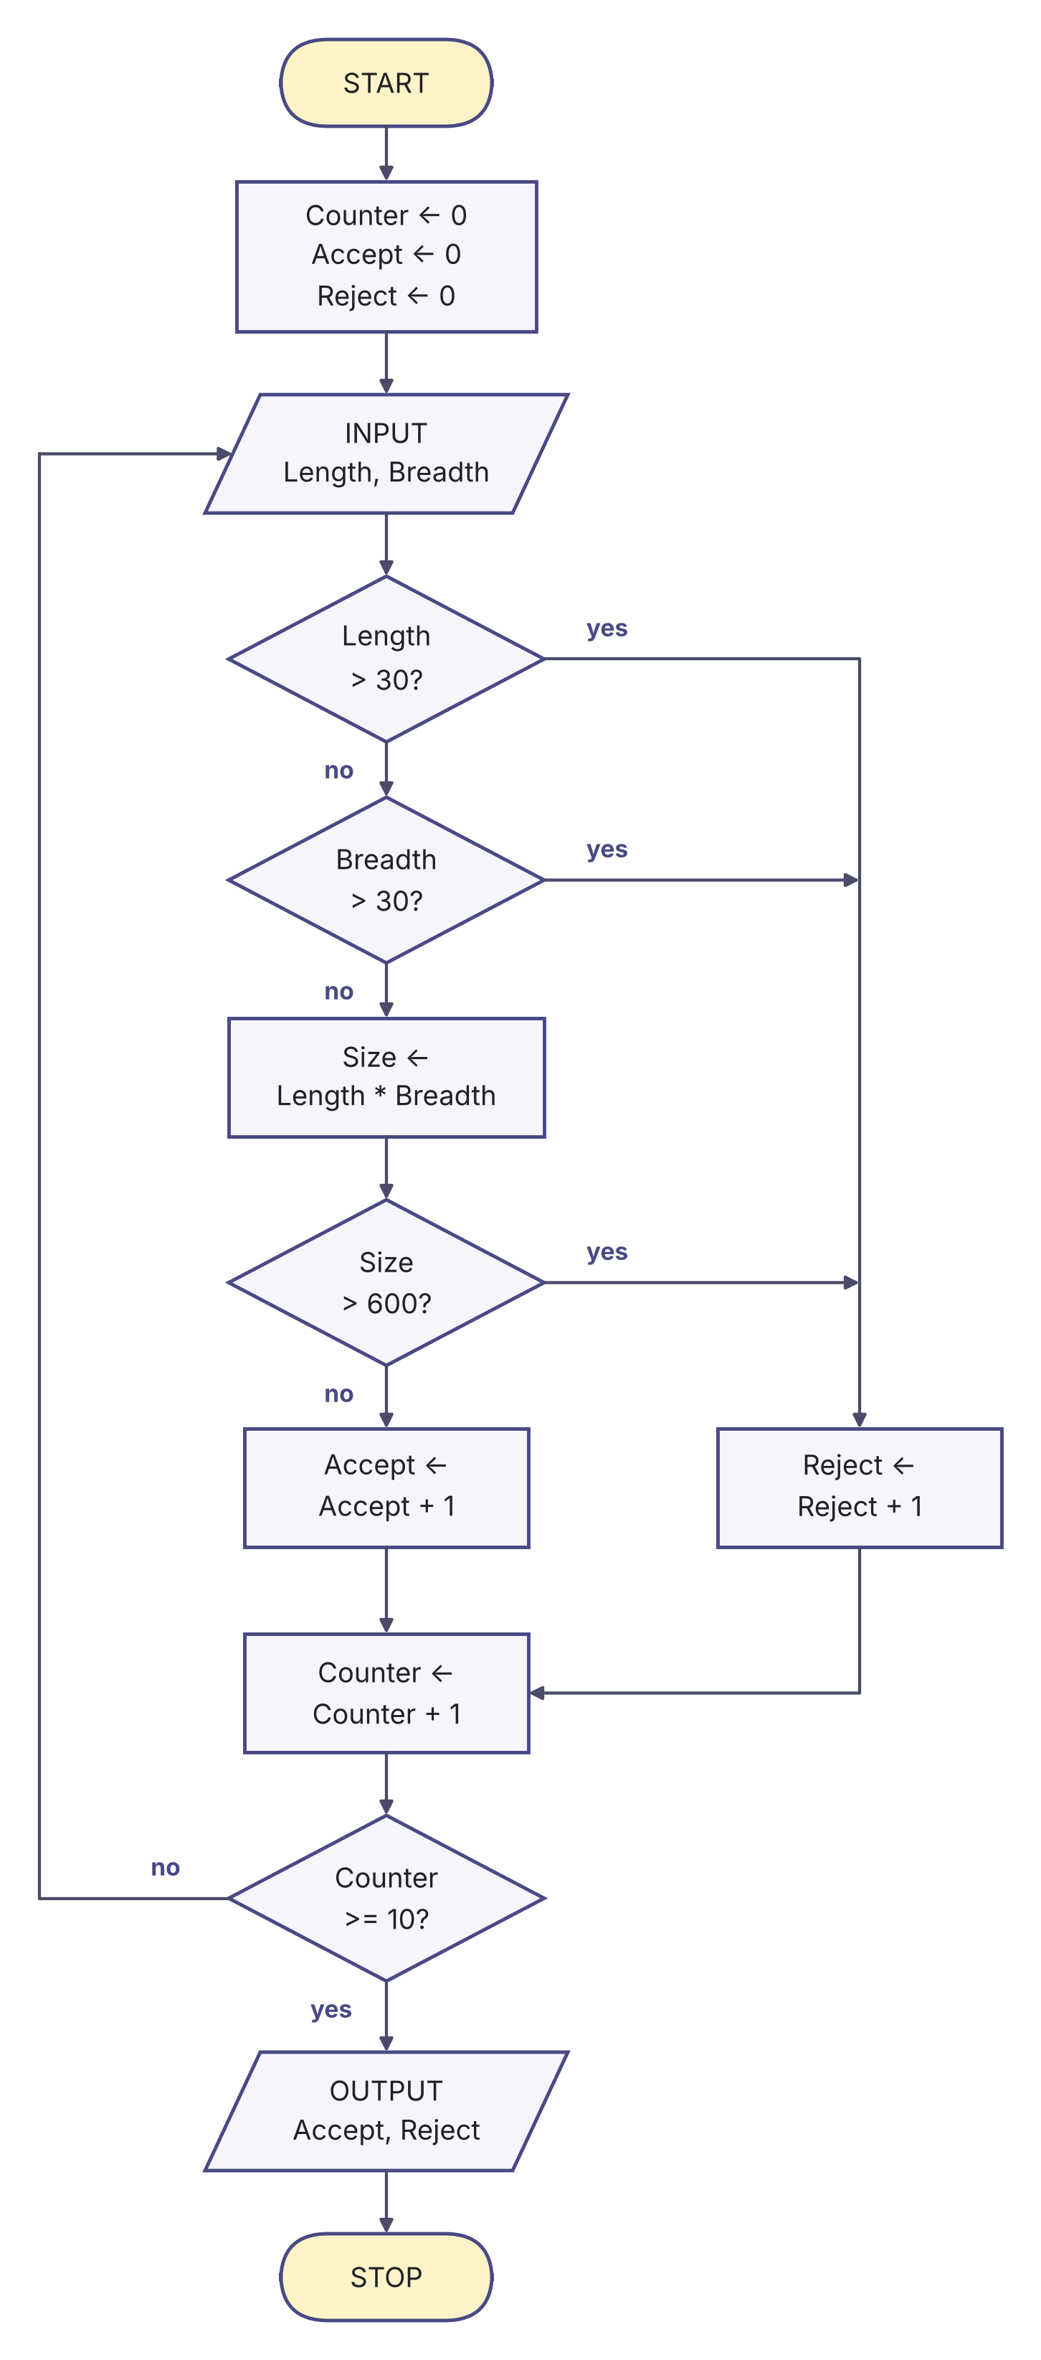 | Use this data to dry run the algorithm in the trace table below:  15, 10, 20, 17, 32, 10, 30, 35, 30, 15, 30, 28, 25, 25, 20, 15, 40, 20, 12, 10  Each pair of values is one parcel: Length then Breadth.  [5]  (c) Identify the rules a parcel must meet to be accepted. [3]
Trace table for (b)
Counter | Length | Breadth | Size | Accept | Reject | OUTPUT

(d) This flowchart gives a grade to each score that is input. An input of -1 ends the process.
Exam-style, based on 0478/21 May/June 2025 Q10
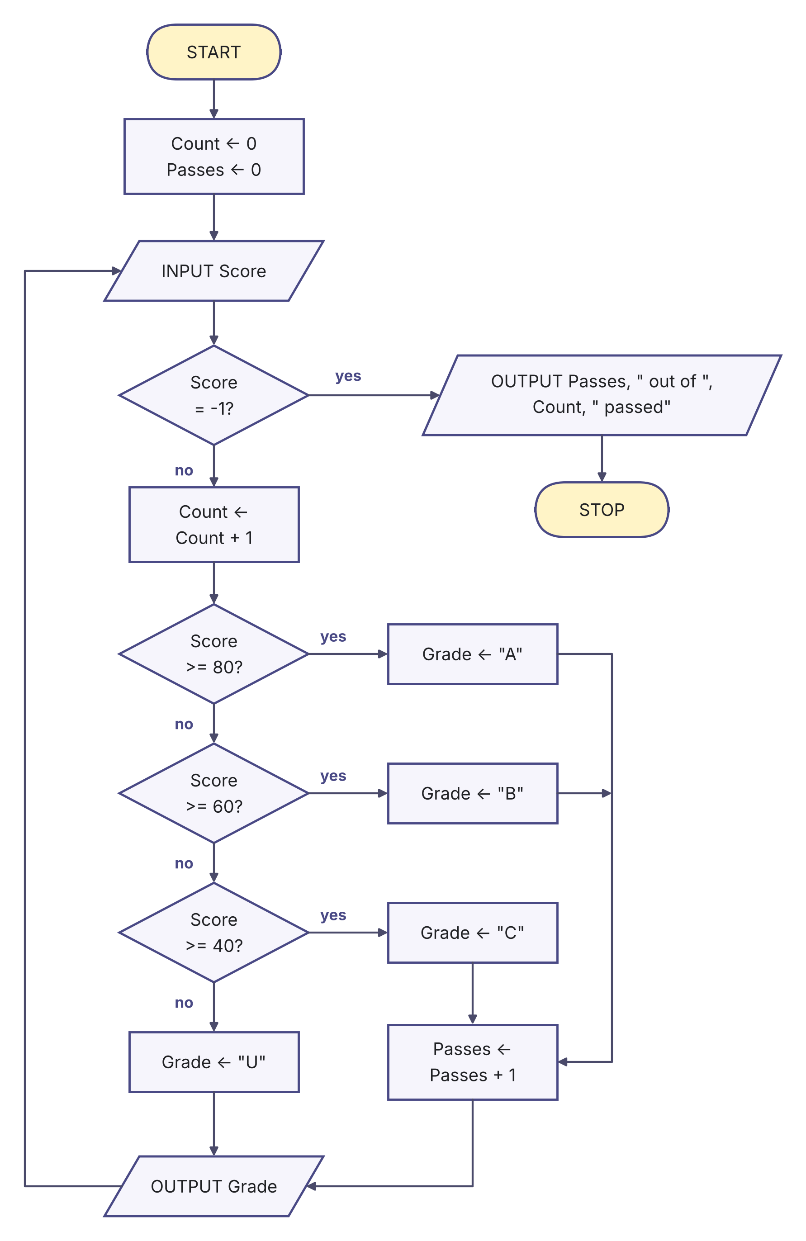 | Complete the trace table for the input data:  72, 39, 80, 55, 40, 18, -1  [4]  (e) The school decides that a score of 90 or more gets the grade A*. Describe the changes needed to the flowchart. [3]
  Score | Count | Grade | Passes | OUTPUT

(f) Complete the trace table for this algorithm when the input is 4072. [4]
Exam-style
INPUT Number
Total ← 0
Digits ← 0
WHILE Number > 0 DO
Total ← Total + MOD(Number, 10)
Number ← DIV(Number, 10)
Digits ← Digits + 1
ENDWHILE
OUTPUT Digits, " ", Total
Number | Total | Digits | OUTPUT

(g) State the purpose of the algorithm in part (f). [2]

Learn Finding and correcting errors
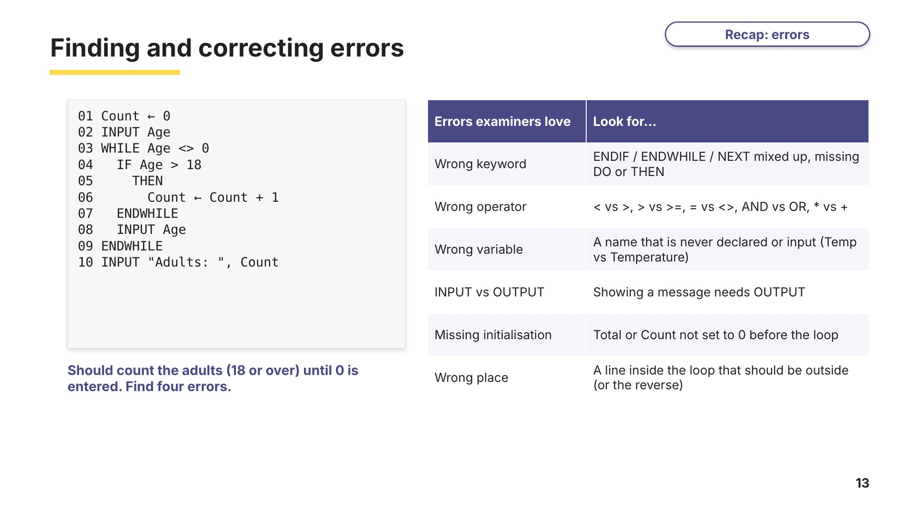
Slide 13 - Finding and correcting errors
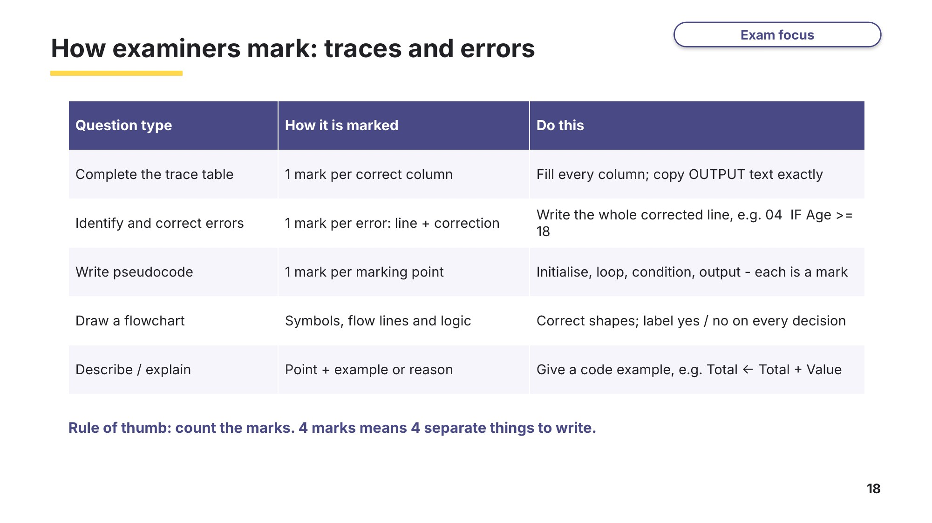
Slide 18 - How examiners mark: traces and errors

Task 6 Find and correct errors [33 marks]
Question 1 Random number of values
This algorithm chooses a random number of values to input, from 1 to 20. It inputs the values, then outputs their total and their average.
0478/21 May/June 2024 Q4
01 DECLARE Loop : STRING
02 DECLARE Limit : INTEGER
03 DECLARE Value : REAL
04 DECLARE Total : REAL
05 Total ← 0
06 Limit ← ROUND(RANDOM() * 19, 0) + 1
07 IF Loop ← 1 TO Limit
08 OUTPUT "Enter a number"
09 INPUT Loop
10 Total ← Total * Value
11 NEXT Loop
12 OUTPUT "The total of the numbers entered is ", Total
13 OUTPUT "The average number entered is ", Total / Limit
(a) Identify the line numbers of the four errors in the algorithm. Suggest a correction for each error. [4]
Line | Correction

(b) Rewrite line 13 so that the average is output rounded to one decimal place. [2]

(c) Explain how you would change the algorithm to make sure each value input is between 1 and 500 inclusive. Any pseudocode you use must be fully explained. [4]

Question 2 Guessing game
This algorithm chooses a random whole number from 1 to 100. The user keeps guessing until they find it. After each wrong guess they are told whether the number is higher or lower than their guess. At the end, it outputs how many guesses were needed.
0478/21 May/June 2025 Q6
01 Counter ← 0
02 N ← ROUND(RANDOM() * 99, 1) + 1
03 REPEAT
04 OUTPUT "Please enter a guess"
05 INPUT G
06 IF G > N
07 THEN
08 OUTPUT "The number is lower than your guess"
09 ELSE
10 IF G < N
11 THEN
12 OUTPUT "The number is lower than your guess"
13 ENDIF
14 Counter ← Counter + 1
15 ENDIF
16 UNTIL G = N
17 OUTPUT "Well done, you took ", Guess, " attempts"
(a) Identify the four errors in the algorithm and suggest a correction for each error. [4]
Line | Correction

(b) Give two ways this algorithm could be made easier to understand and maintain. Use an example from the algorithm for each. [2]

Question 3 Patient temperatures
This algorithm checks patient temperatures. An input of 999 ends the process.
0478/21 Oct/Nov 2024 Q9
01 REPEAT
02 OUTPUT "Please enter temperature "
03 INPUT Temp
04 IF Temperature = 999
05 THEN
06 IF Temperature > 38.0
07 THEN
08 OUTPUT "Temperature too high"
09 ENDIF
10 IF Temperature < 35.0
11 THEN
12 OUTPUT "Temperature too low"
13 ENDIF
14 IF Temperature >= 35.0 OR Temperature <= 38.0
15 THEN
16 OUTPUT "Temperature normal"
17 ENDIF
18 ENDIF
19 WHILE Temperature = 999
(a) Identify the line numbers of the four errors in the pseudocode and suggest a correction for each error. [4]
Line | Correction

(b) Identify the range of temperatures that the algorithm treats as normal. [2]

(c) Complete the trace table for the corrected algorithm using this data: 34.22, 36.1, 37.4, 38.0, 999, -1 [2]
Temperature | OUTPUT

Question 4 Ten positive numbers
This algorithm should add up 10 positive whole numbers and output the total. It contains several errors.
Cambridge IGCSE Computer Science coursebook (Hodder), exam-style question 7
01 Counter ← 1
02 FOR Counter ← 1 TO 10
03 REPEAT
04 OUTPUT "Enter a positive whole number "
05 INPUT Number
06 UNTIL Number < 0
07 Total ← Total + Counter
08 Counter ← Counter + 1
09 OUTPUT Total
10 NEXT Number
(a) Identify all the errors in the algorithm. [5]

(b) Rewrite the algorithm so that it is effective and error free. [4]

Learn Developing programs
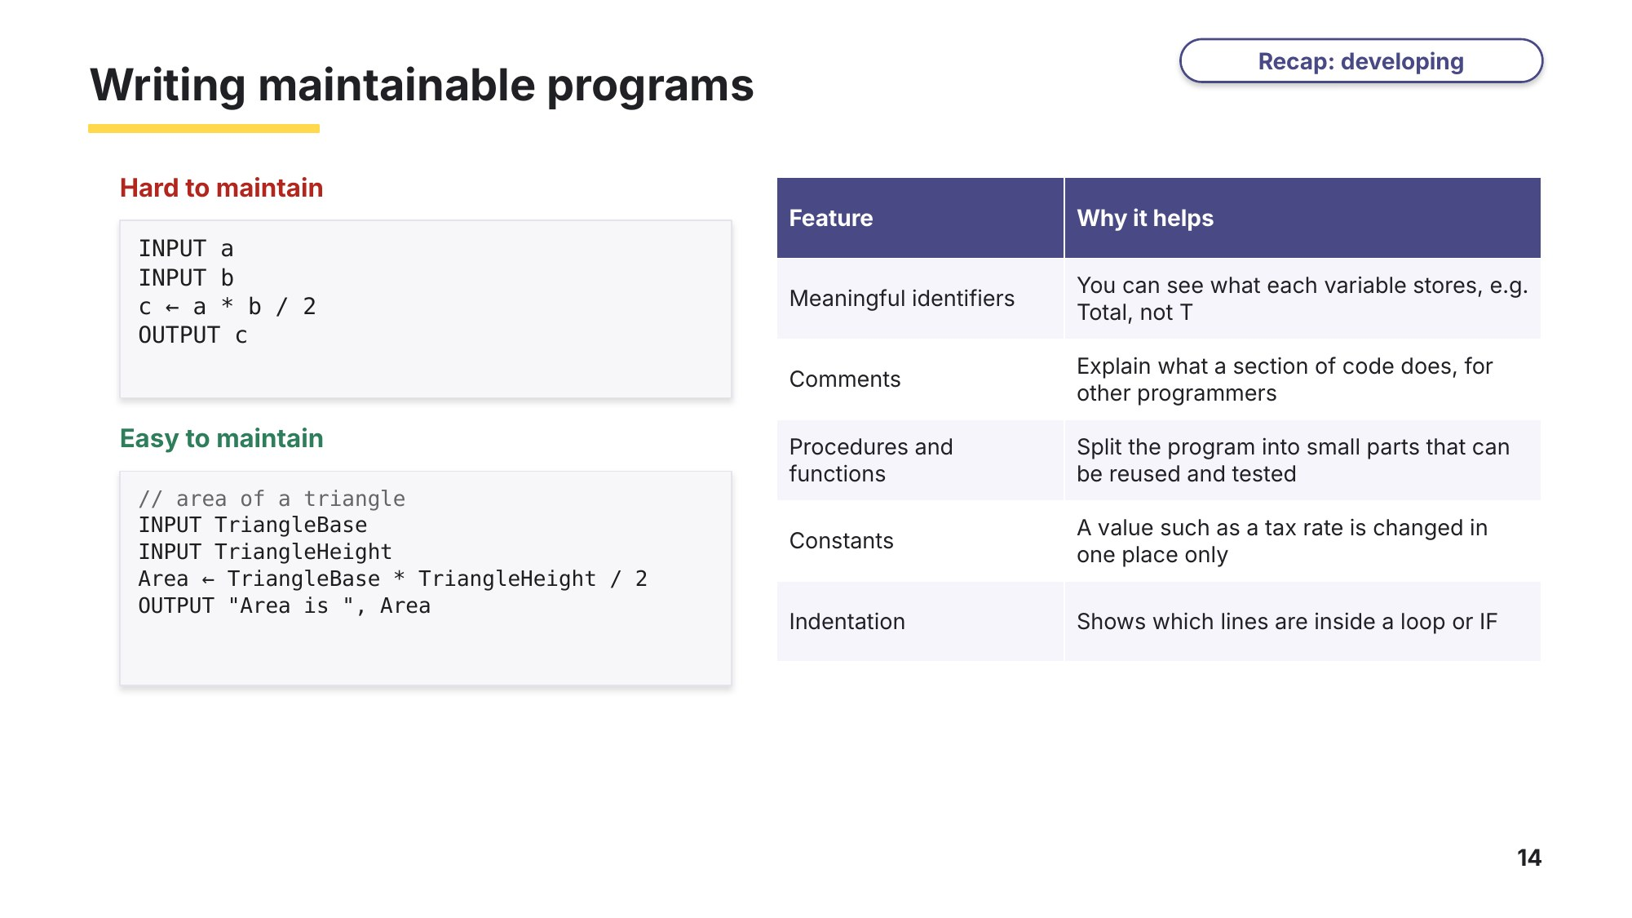
Slide 14 - Writing maintainable programs
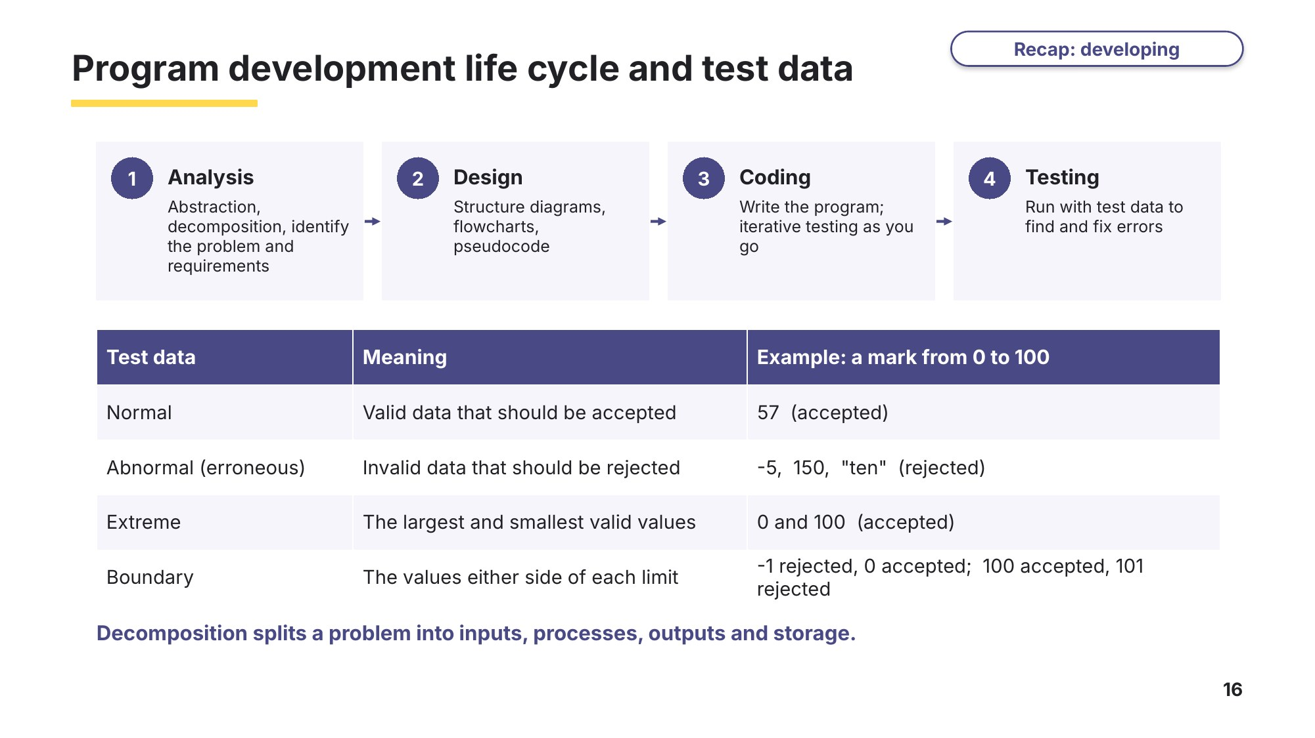
Slide 16 - PDLC and test data

Task 7 Developing programs [28 marks]
(a) Write the stage of the program development life cycle next to each description. Choose from: analysis, coding, design, evaluation, testing. One stage is not used. [4]
Based on 0478/21 May/June 2023 Q1(a)
Description | Stage
Writing and implementing the instructions that solve the problem
Detecting and fixing the errors in the program
Identifying the problem and its requirements
Developing an algorithm using structure diagrams, flowcharts or pseudocode

(b) When a problem is decomposed it is broken down into its component parts. Name and describe three of these component parts. [3]
Based on 0478/21 May/June 2023 Q1(b)

(c) Describe three methods that can be used to design a solution to a problem. [6]
Based on 0478/21 Oct/Nov 2024 Q5

(d) A phone app splits the cost of a restaurant bill equally between the diners. It must work for 1 to 12 diners and for bills from $10 to $500.
Cambridge IGCSE Computer Science coursebook (Hodder), exam-style question 3
(i) State the validation checks that should be used for the number of diners and the size of the bill. [2]

(ii) Give two sets of normal test data and their expected results. [4]
 | Number of diners | Bill ($) | Expected result
Set 1
Set 2

(iii) Give one item of abnormal (erroneous) test data. [1]

(iv) Identify the boundary data needed for the number of diners and the bill, with the expected result for each value. [4]

(e) Look at this algorithm.
Exam-style, based on 0478/21 Oct/Nov 2024 Q6(c)
A ← 0
B ← 0
INPUT C
WHILE C <> -1 DO
A ← A + C
B ← B + 1
INPUT C
ENDWHILE
OUTPUT A / B
(i) Suggest meaningful identifiers for A, B and C. [2]

(ii) Write a comment that could be added at the start to explain what the algorithm does. [1]

(iii) Rewrite the last line so that it outputs a suitable message and the result rounded to one decimal place. [1]

Task 8 Extension: car park program [24 marks]
A car park charges drivers by the number of whole hours they park:
- up to and including 2 hours: $3.00
- each extra hour after the first 2: $1.50
- the most any car pays is $20.00.
The number of hours must be a whole number from 1 to 24. The attendant enters 0 when the car park closes.
Exam-style, in the format of the 15-mark 0478 Paper 2 programming question
(a) Predict the charge for each of these cars before you write any code. [4]
Hours parked | 3 | 1 | 14 | 7
Charge ($)

(b) Write an algorithm in pseudocode that: [15]
- inputs the number of hours for each car, and rejects and re-inputs any value that is not 0 or a whole number from 1 to 24
- calculates and outputs the charge for each car
- when 0 is input, outputs the number of cars, the total takings, the average charge rounded to two decimal places, and the highest charge, each with a suitable message.
You must use pseudocode and include comments to explain how your algorithm works. Use meaningful identifiers.
(c) Draw a flowchart for the part of your algorithm that calculates the charge for one car, given Hours. [5]

Learn Review
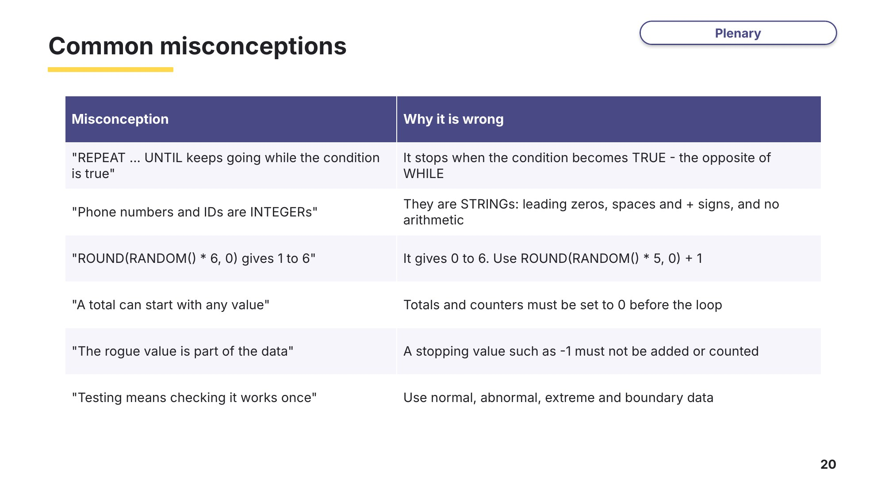
Slide 20 - Common misconceptions
Look back at your Task 1 answers. Would you change any of them now?

Learn Exit question
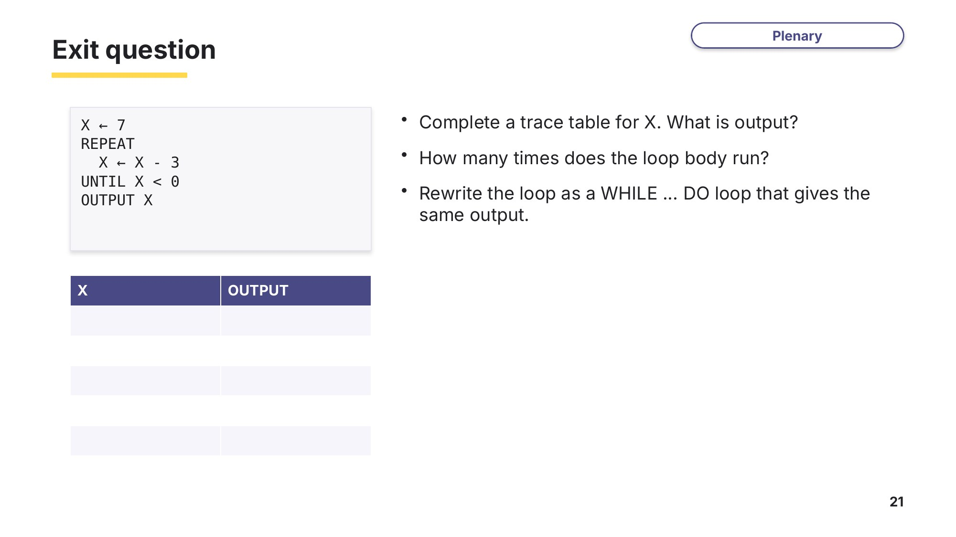
Slide 21 - Exit question

